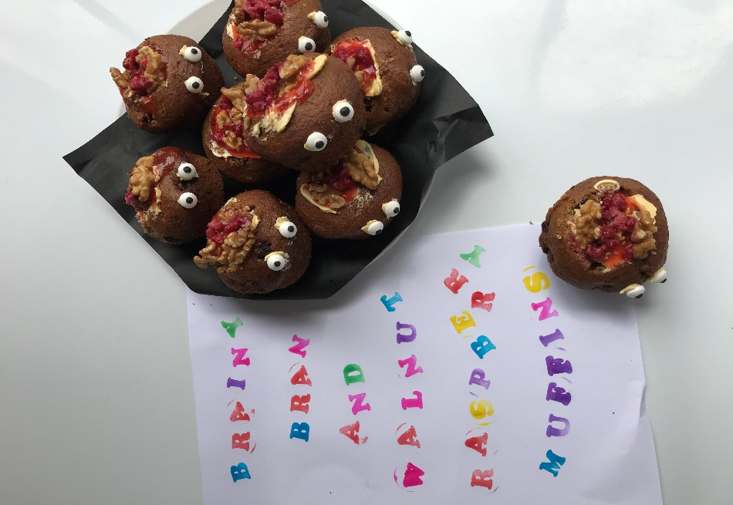**Six Week Brainy Breakfast Bran Raspberry and Walnut Muffins.**

**This Recipe is great to make up the batter and leave in the fridge until you are ready to cook the muffins. They are yummy and healthy to have for a breakfast muffin. Batter lasts 6 weeks in the fridge.**

**Wet Mix: Dry Mix:**

**1 cup Sugar 3& ¾ cups Plain Flour**

**½ cup Brown Sugar 2& ½ tsp Bicarb Soda**

**½ cup oil 1 cup Sultanas**

**2 Beaten Eggs Pinch Salt**

**2 cups Bran Topping: butter or**

**2 cups Milk Margarine, raspberry**

**1 cup Boiling Water Jam, fresh or frozen**

**Method: Raspberries & Walnuts**

**Soak bran in boiling water for 5mins**

**Beat oil, sugar and eggs**

**Add bran and water**

**Sift flour, soda and salt**

**Add flour mixture and milk alternatively to oil mixture**

**Add sultanas**

**Bake 200 degrees c for 20 – 25 min**

**Makes 4 dozen:**

**For Brain Decoration:**

**Scoop out a small amount off the top of the muffins. Spread a small amount of butter, then the jam. Add your walnut brains then sprinkle chopped pieces of raspberry for brain ventricles. Place candy eyes on the side of the muffin with a dob of butter or margerine for the eyes.**