FUN AND HEALTHY SPAGHETTI BRAIN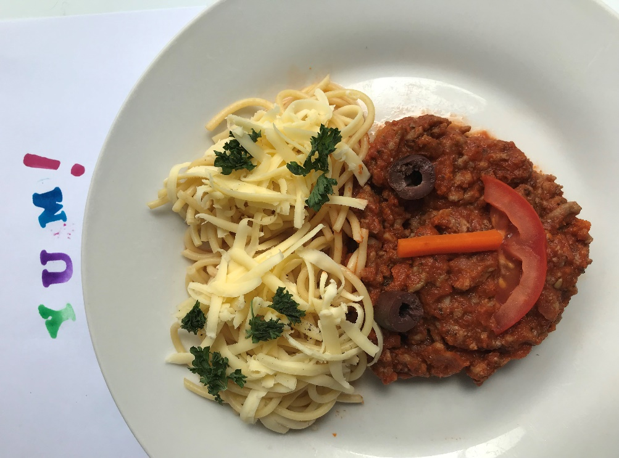

BOLOGNESE!

We all love a good Bolognese; the trick is to hide as many vegetables as you can in your Bolognese sauce. Your kids will love it and you are getting them to eat some healthy vegetables. Also, they can be creative in serving their Bolognese themselves to make a fun face with a healthy Brain. If your child is only little you can have some fun in coming up with a creation yourself.

Ingredients: 500gms Beef Mince, ¾ cup Water, Tomatoe Paste, 1 Tin Roma Tomatoes drained, reserve liquid, Tomatoes chopped, 1 Onion chopped finely, 1 Zucchini grated, 1 carrot grated, small eggplant sliced and salted leave for ½ hour rinse and chopped into pieces, 1 red or green Capsicum finely chopped, 4 or 5 button mushrooms chopped, 1 handful of chopped Parsley, 1 sprig of Rosemary torn from stem, 1 Bay leaf, 1 or 2 Cloves Garlic. Crushed black Pepper Corns, Olive Oil. ½ pkt 600gm Of Spaghetti, a pinch of Salt.

Note: If you are in a hurry and want to rustle up a quick Bolognese sauce? There are some ready-made Pasta Sauces on the market that are pretty good, then you could add the prepared and sautéed vegetables to your sauce.

Method: Drain Roma Tomatoes and prepare vegetables. Crush garlic. Pour 1 tblspoon of Olive Oil into pan. Sautee onion until softened add chopped Carrot stir for 1 minute. Add chopped Capsicum, Eggplant, Zucchini and Mushrooms, stir until softened. Add Tomatoes Paste, reserved Liquid and Water. Add Parsley and Rosemary, Pepper Corns. Add Bay Leaf, simmer for half hour on low heat or until thickened, stirring occasionally. In the meantime, prepare a pot of salted water, bring to the boil, add a dash of Olive Oil, Spaghetti and simmer until cooked. Drain Spaghetti. Serve topped with cooked Pasta Sauce with the Bay Leaf removed and sprinkle with Grated Parmesan Cheese or a preferred Cheese.

This is where your Child can help to be creative in serving their own meal, making their own face and brain They can use pieces of vegetables used in the sauce or anything else you may have on hand!

Enjoy!